
GISMA University of Applied Sciences

Project Management (M502)

Project: Ecopack Business Expansion in Germany

Submission Date: 26 – Jun – 2026
Submitted to: PROF. Peter White

Submitted by:
Aniket Sonu - GH1048274
Shravani Amit Borkar - GH1058569
Sukhdeep Singh- GH1041755
Heli Vijaybhai Kanpariya - GH1057191

This report will show a project management plan for ECOPACK Business, a packaging company focused on producing environmentally friendly packaging products for restaurants, cafés, and food delivery businesses. This project object is to expand the business in Germany within a 24-month project duration and an allocated budget of €900,000.
The Report adopts a pure agile project management methodology where all the digital platform development will happen to allow complete cloud-based operations and flexibility, iterative improvements, and customer feedback integration.
Key stakeholders include investors, suppliers, employees, customers, technology developers, and government. Effective communication and stakeholder engagement strategies are required to manage expectations and maintain project.
Risk assessment identifies supply chain disruptions, budget overruns, software development issues, and regulatory changes as major project risks. Appropriate mitigation measures and contingency planning are proposed to reduce potential impacts.
The report concludes that successful project delivery depends on strong planning, effective stakeholder management, proactive risk control, and the ability to adapt to changing market conditions.
Project Overview
Ecopack is a packaging company that operates on delivering workable, innovative, and environment friendly packaging solutions. As global demand for eco-friendly products continues to increase, expanding operations into Germany makes a strategically important growth initiative for the company.
The scope of this project is to establish Ecopack’s business in Germany through market entry planning, regulatory compliance, operational setup, partnership development, and customer purchase. This project will analyze the market opportunities, identify key industries and customers, to develop a best strategy to enter in market with alignment of Germany’s trade policies.
Germany is selected due to its large economy, strong manufacturing base, increasing environmental awareness, and growing demand for sustainable packaging solutions. Successfully entering the German market will support Ecopack’s international footprint.
Project Objectives
- To establish Ecopack’s business structure in Germany.
- To analyze the German packaging market, customer demand, competitors, and requirements.
- To build businesses with distributors, suppliers, and potential clients within Germany.
- To achieve opening market capture and brand recognition in target sectors.
- To ensure compliance with German government policies, environmental and trade regulations.
Objective | Measurement Target
Complete manufacturing facility setup | By Month 6
Develop and launch digital ordering platform | By Month 12
Recruit operational workforce | 25 employees by Month 15
Acquire initial customer base | 100 business customers within 6 months after launch
Maintain budget performance | Remain within €900,000 budget
Achieve production readiness | Full operational status by Month 20

Success Criteria
- Successful registration and establishment of Ecopack’s business operations in Germany.
- Completion of market research and implementation.
- Achievement of initial customers, partnerships, or distribution agreements within the first operational phase.
- Full compliance with German, environmental, and packaging Rules.
- Achievement of predefined sales, revenue.
Justification of Project Management Approach: Agile Methodology
For the EcoPack project, an Agile project management approach is selected because the project includes the development of a digital platform. Agile is suitable for software and technology projects where requirements develop over time and constant stakeholder feedback is important for success. Each sprint delivers a functional component of the platform, allowing stakeholders to review progress and provide feedback throughout the project lifecycle. One of the main reasons for choosing Agile is the uncertainty associated with user requirements. As EcoPack Connect aims to serve both suppliers and business customers, their needs may change during the development process. Agile allows the project team to respond quickly to these changes without significantly disrupting the overall project schedule. Moreover, regular sprint reviews and demonstration and feedback will ensure the product quality. Furthermore, Agile gives the flexibility to work in cross functional teamwork. This collaborative environment improves project efficiency and enhances the quality of project outcomes.
Benefits of Agile
Flexibility in changing business and user requirements.
Continuous stakeholder engagement and feedback.
Faster delivery of functional platform features.
Early identification and mitigation of technical issues.
Improved collaboration among project team members.
Higher customer satisfaction through incremental improvements.

Limitations of Agile
Agile also has certain limitations. Continuous stakeholder involvement requires significant time and commitment from users and project sponsors. In addition, frequent changes in requirements may create challenges in cost estimation and long-term planning. Agile projects can also experience scope expansion if changes are not managed carefully.
However, these limitations can be mitigated through effective sprint planning, prioritization of requirements, and regular communication between stakeholders and the project team.

Project Charter:
We have created a project charter for our project. Please find the link below.
{Project-Management-Repo/project charter.docx at main · AniketSonu/Project-Management-Repo}

In this charter we have explain a formal document that officially authorizes a project and provides a high-level overview of its purpose, objectives, scope, stakeholders, budget, and expected outcomes. It acts as a reference point for everyone involved in the project and gives the Project Manager authority to use resources and manage project activities.
The Project Charter display a foundation of the Ecopack project. It creates a understanding among stakeholders, explains expectations, and offers direction for planning and execution.
Jira Implementation
We used Jira platform to demonstrate the agile method for our project. As it has already all feature like Kanban board, task scheduling, team assignment, Approval list, continuous feedback, sprint, backlogs and many more. We tried to use all the features on the Jira and demonstrate a real-world project how a project works in agile environment and we also calculate the sprint points according to the efficiency given by the people who will work on the project.
Please find the link below for the Jira project.
{ https://sukhdeep690.atlassian.net/jira/core/projects/EBEIG/board?filter=&groupBy=none&atlOrigin=eyJpIjoiMmQ1ZjdhMTBkZDQ4NGRmMmExNjU0ZGJmY2JkY2QxYWEiLCJwIjoiaiJ9 }
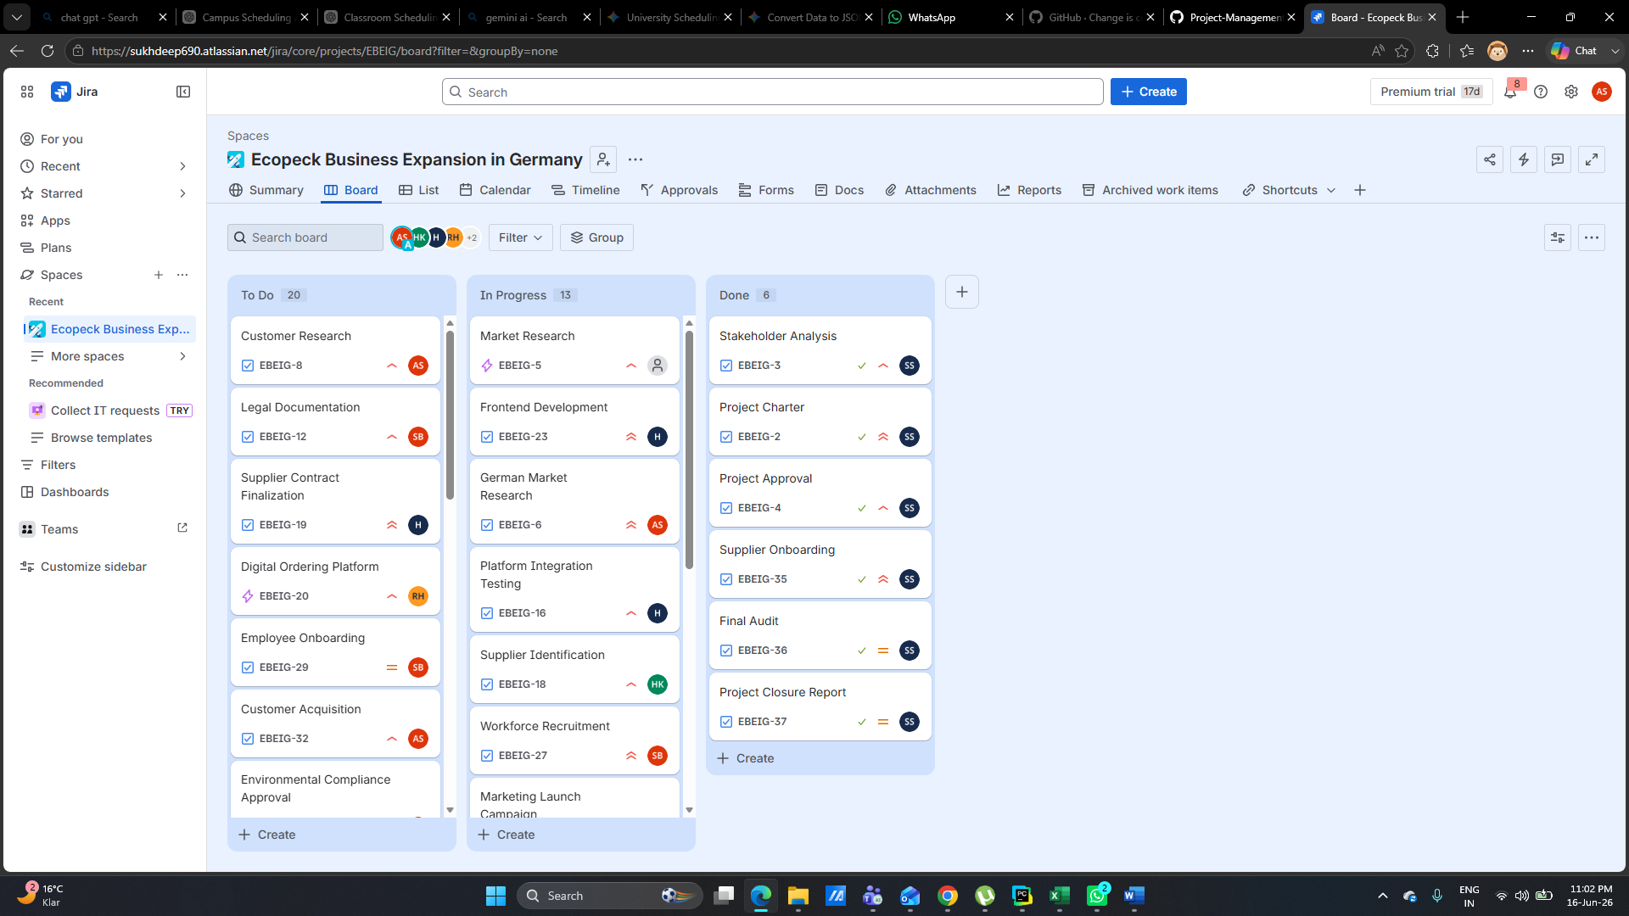
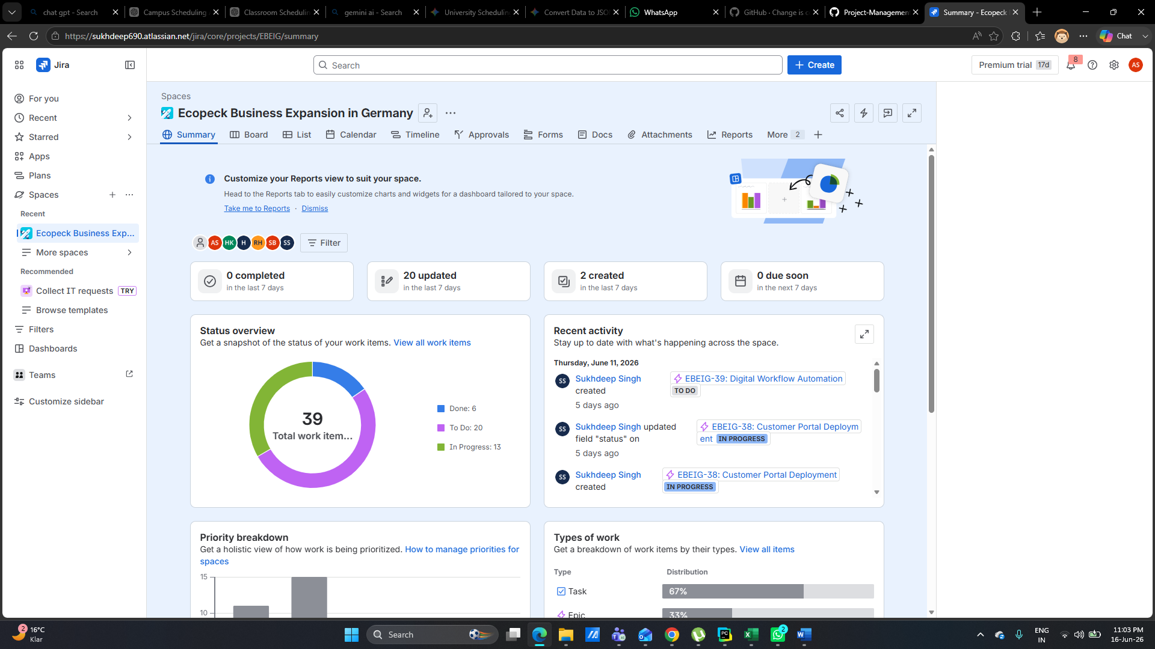
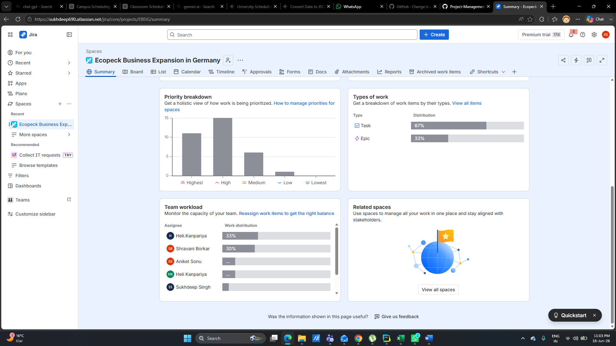

Project Cost Management
The cost management are very Important to ensure the successful expansion of Ecopack into the German market within the planned 24-month timeline and approved budget of €900,000. The project schedule is divided into several phases, research of the market and customer requirement (Months 1–6) will cost 100000€ , digital platform development using Agile sprints (Months 6–12)will cost 300000€, workforce recruitment and training (Months 10–15) 200000€, production testing and operational readiness (Months 16–20) 100000€,, and market launch with customer acquisition activities (Months 21–24) 200000€,.

Stakeholder and Communication Management
Key stakeholder groups within the Ecopack business ecosystem are
1. Project Sponsor - They provide funding and strategic directions. They are highly interested and influenced. They also hold high power in the company.
2. Project Manager - Leads and controls projects actively in the company. Highly interested, influenced and powerful in company.
3. Client / Customer- These are the final project deliverables. They are highly interested, influenced and powerful.
4. Project Team Members - They don’t have much power in company, but their interest level is high. They execute the project tasks. They have higher influence on project.
5. Functional Managers - They hold a high power in a company, also have high influence on project. They provide resources and support to the company.
6. Suppliers / vendors- Deliver goods and services to the company. They hold medium power, interest and influence on the company.
7. End users- They are the final product users with low power level and highly interested. They are mildly influenced on project.
8. Government/ Regulatory Authorities- Ensure compliance with regulations with high power and influence on project. They are less interested.
9. Local community/ Public- They are affected by project outcomes. They are low interested and influenced on project.
Communication and Engagement Strategies:
Ecopack avoids a “one size fits all” approach to communication. Instead, information loops are tailored to the specific needs of each stakeholder group to build institutional trust and operational alignment.
1. Manage Closely - Project Sponsors, Project Manager, Client/ Customers are the stakeholders who are managed Closely. They are kept informed by regular meetings and reports, daily communications, progress reports and reviews.
2. Kept Satisfied- Functional Managers and Government/ Regulatory Authorities are kept informed through Status updates and compliance reports.
3. Kept Informed- Project Team Members and End Users are updated by team meetings, emails, surveys and training sessions. Ecopack operates transparent, proactively adhering to safety standards and environmental regulations.
Sustainability at Ecopack
Sustainability is a key aspect of Ecopack’s business strategy. As a manufacturer of industrial baking cups and molds, Ecopack focuses on balancing economic growth, environmental responsibility, and social commitment. By integrating sustainable practices into its operations, the company aims to create long-term value for customers, employees, and society while minimizing its environmental impact. From an environmental perspective, Ecopack promotes sustainability through the efficient use of raw materials and advanced manufacturing technologies. The company strives to reduce material waste by using automated production systems that optimize paper and other packaging materials during the manufacturing process. This helps conserve natural resources and lowers production costs.
Risk Management & Resource Allocation:
A risk register is a document used in project management to identify, assess, monitor, and control risks that may affect a project. The Ecopack project risk register identifies threats and opportunities that may influence the successful establishment and operation of the company. Each risk is assessed based on its probability (likelihood of occurring) and impact (severity of consequences).
Probability and Impact Analysis
Probability Analysis - Probability measures how likely a risk is to happen. Very unlikely, almost certain. Most risks in the register have a probability score of 4, indicating they are likely to occur during the project lifecycle. Impact Analysis - Impact measures the seriousness of the consequences if the risk occurs. Negligible impact Severe or critical impact. The majority of risks have an impact score of 5, meaning they could significantly affect project cost, schedule, quality, compliance, or business performance.
Severity Analysis
Severity is calculated as:
Severity = Probability × Impact
4 × 5 = 20
A severity score of 20 represents a high-priority risk that requires continuous monitoring and mitigation.
Risk Analysis
Delay in German Business Registration The company registration process may take longer than expected because of administrative procedures, documentation issues, or government approval delays, which impacts in delay of project startup, hiring processes and also in obtaining permits and contracts. Mitigation and Contingency Plan This can be done by hiring experienced legal consultants, preparing documentation in advance and maintaining communication with registration authorities. Some contingency plan for this risk is by escalating the matter to a legal firm and prioritizing the activities that do not require final registration.
Environmental Compliance Approval Delay, Environmental permits and sustainability certifications may take longer to obtain. The impacts of these are prevention of production, increase in project costs and delays in facility operations.
Mitigation and Contingency Plan
Conducting compliance reviewing before submission and maintaining regular contact with regulatory authorities might help in risk reduction. The alternative plan for this type of risk is using external consultants to speed up the approval or implementation of temporary operational alternatives if allowed.
Manufacturing Facility Setup Delay
Construction, renovation, leasing, or installation activities may take longer than planned, this results in delays of customer deliveries and production readiness, increasing labor and contractor costs.
Equipment Procurement Delays
Machinery and packaging equipment may not arrive on time due to supplier shortages or logistics issues. This will impact on revenue loss, increased operational costs and delays in production startups. Mitigation and Contingency Plan The protective measures will be tracking shipments regularly, maintaining strong relationships with suppliers and ordering the equipments early. Sourcing equipment from secondary suppliers or, lease the equipment temporarily will be reserve plan
Budget Overrun Beyond €900,000
Project expenses may exceed the approved budget due to inflation, scope changes, or unexpected costs. This results in reduced profit rate, delayed project activities and also shortages in funding.
Supplier Contract Failure
Suppliers may fail to deliver products or services according to contractual requirements. Disruptions in production, dissatisfied customer and increase in procurement costs are the impacts of these risks on company and production.
Mitigation and Contingency Plan
For minimization of risk maintaining multiple suppliers, including penalty clauses in contracts, building strategic supplier relationships. Maintaining safety stock inventory, sourcing out the materials from alternative suppliers and having a backup vendor contracts acts as an alternative plan.
Digital Platform Development Delay
Development of the online ordering platform may take longer than expected. Efficiency is reduced in operational sectors, late customer onboarding and missing sales opportunities are the impacts of this risk.
Cybersecurity Breach on Platform
Hackers, malware, or unauthorized users may gain access to business systems. This impacts legal liabilities, data loss, operational disruption and reputation damage.
Difficulty Recruiting Skilled Workforce
Labor shortages and competition in Germany may make hiring qualified employees difficult, which results in less productivity, increase in labor costs and late in operations.
Low Customer Adoption in Germany
Customers may be reluctant to switch to Ecopack products, which low down the revenue, slow down the business growth and also decreases the market share. Strong Local Competition Existing packaging companies may aggressively compete on price and service, which impacts on reducing market penetration, challenges in facing customer acquisition and also lower down the profit margins.
Raw Material Shortages
Supply chain disruptions may reduce the availability of sustainable packaging materials. This risk affects in cost increase, missing customer orders and production interruptions.
Product Quality Issues
Manufacturing defects or quality control failures may affect product performance, product returns, customer complaints and also reputation damage.
Currency Exchange Fluctuations
Changes in exchange rates may increase procurement costs. This impacts on reduction in profit, financial planning challenges and also budget uncertainty. Distribution Network Delays Transportation and logistics issues may delay product deliveries. This effects on revenue loss, increased logistics costs and also customer dissatisfaction.
Risk Register
We also created a risk register to cover all the risk that will affect the business which link is below,
{Project-Management-Repo/risk-register-updated.xlsx at main · AniketSonu/Project-Management-Repo}
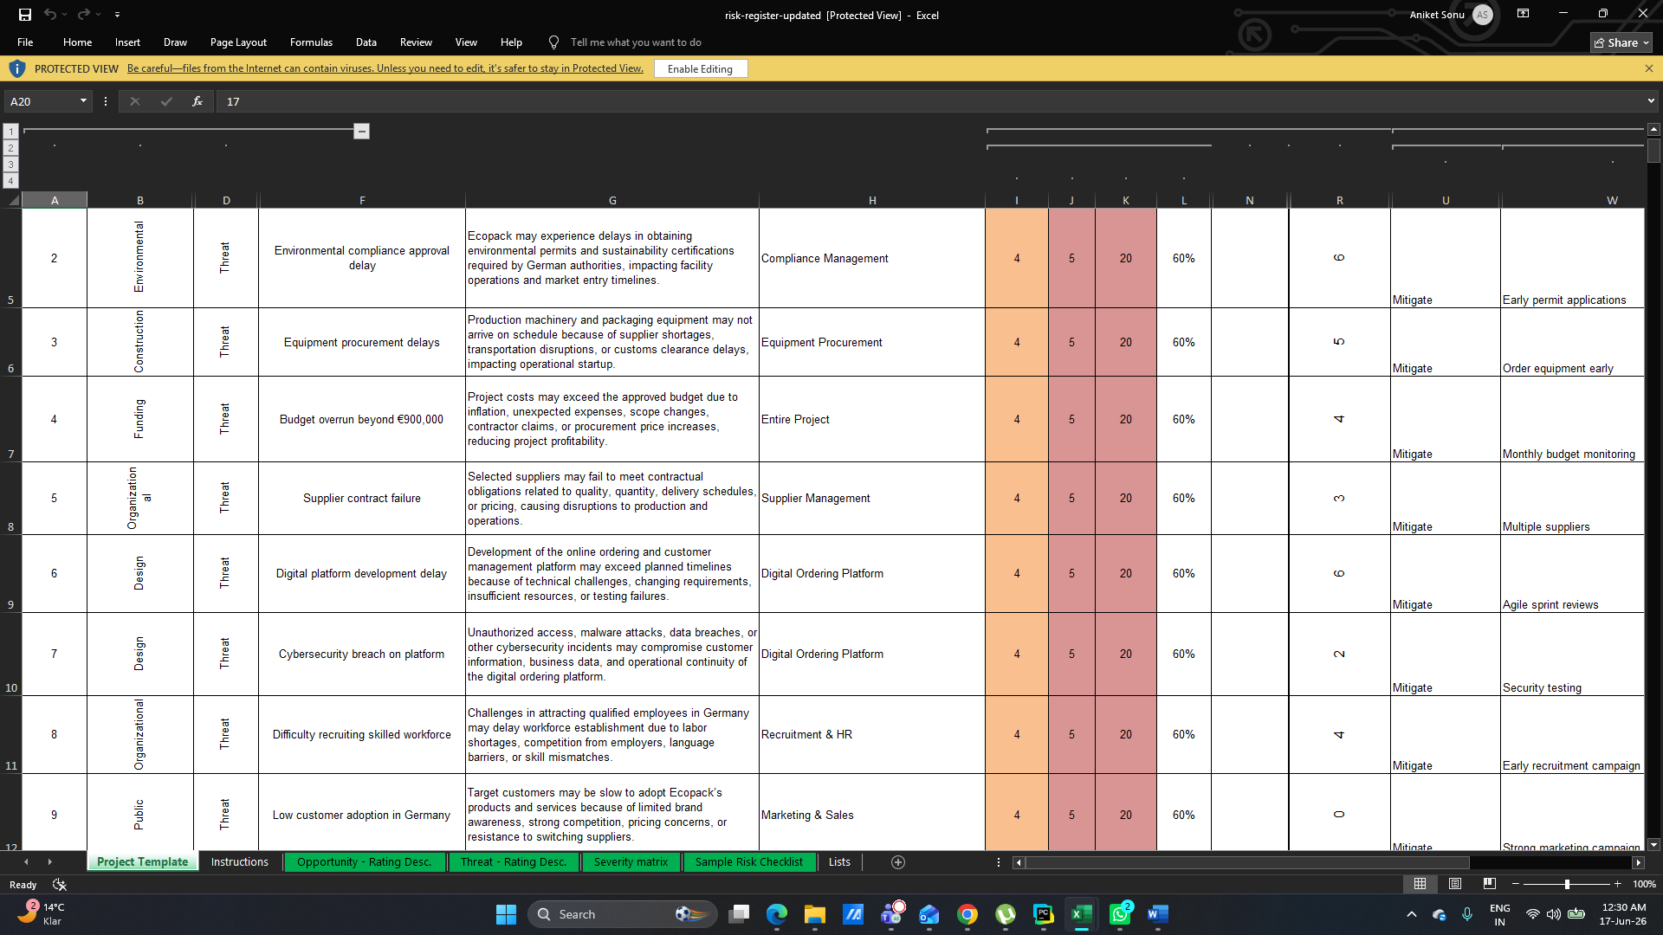
Market Expansion Strategy
To guarantee a successful entry into the German market, we have to think about expansion strategy that focuses on building strong local partnerships and establishing a sustainable supply chain network. In the first phase, the company will do the detailed market research to identify high-demand locations, good distributors, and key customer segments within the food service and packaging industries. The second phase will work on making good relationships with local suppliers, logistics people, and business customers and improve operational efficiency. Ecopack will control its digital ordering platform and targeted marketing campaigns to increase brand awareness, attract new customers, and support long-term business growth. This approach reduces risks while creating a strong foundation for sustainable expansion in Germany.
Critical Evaluation and Reflection
The Ecopack project uses an agile project management approach to develop an online marketplace that connects packaging suppliers with business customers. While Agile is well suited to digital projects. One of the main challenges of the project plan is the doubt involved in developing a new digital platform. The budget of €900,000 and a timeline of 20 months fixed, but it is difficult to predict every aspect that may cause any issue during development. User requirements can also be change, technical problems may occur, and unexpected costs could affect the main plan. In addition, the success of the platform depends on attracting enough suppliers and business customers. The platform is delivered on time and within budget, low user adoption could reduce its overall business value.
Agile remains the most appropriate approach for EcoPack Connect. The digital marketplace operates in a fast-changing environment where customer expectations and market conditions can evolve quickly. Agile allows the team to develop the platform in stages, gather feedback, and make improvements throughout the project rather than waiting until the end. This increases the likelihood of delivering a platform that meets user needs and provides real value to the business.
Several valuable lessons can be learned from this project. First, stakeholder engagement is critical for success. Involving suppliers and customers throughout the development process helps ensure that the platform is designed around actual user needs. Second, risk management should be treated as an ongoing activity rather than a one-time task. Risks such as cybersecurity threats, budget overruns, and low user adoption must be monitored continuously so that appropriate actions can be taken when necessary.
Another important lesson is the need for flexibility. Digital projects rarely follow a perfectly predictable path, and project teams must be prepared to adapt when circumstances change. Agile supports this by encouraging continuous improvement and learning throughout the project lifecycle. Finally, effective communication plays a key role in project success. Regular meetings, progress updates, and feedback sessions help build trust among stakeholders and ensure that everyone remains aligned with project goals.
Overall, the EcoPack Connect project highlights that successful project delivery requires more than simply following a plan. In dynamic environments, project managers must balance structure with flexibility, manage stakeholder expectations, and respond effectively to risks and change. These lessons are essential for delivering successful digital projects and achieving long-term business objectives.
Conclusion
The Ecopack Business Expansion in Germany project show a method to entering a new international market using sustainable packaging solutions. The project combines operational development, digital transformation, and environmental responsibility to establish a strong business in one of Europe's largest and most environmentally friendly economies.
In this report, main project management principles have been applied to define project objectives, scope, stakeholder engagement strategies, risk management processes, resource allocation, schedule planning, and cost control measures. Agile project management methodology provides the flexibility required to manage changing business requirements, particularly during the development of the digital ordering platform.
In conclusion, the successful delivery of the Ecopack project will depend on strong leadership, stakeholder partnership, continuous development, and adaption of changing market conditions. The project has the potential to strengthen Ecopack's competitive position, achieve sustainable business growth, and establish a strong foundation for future international expansion.

